Ghost Terminology for Newbies
A Ghost Saddle is comprised of three main components – a base, a seat, and panels. The base and panels are designed to distribute rider weight together.
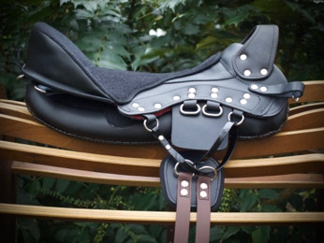
The Base
Pommel
Cantle

Stirrup rings
Girth Rigging

The cantle may be ordered standard (pictured), lower, or higher (2.5cm common, 4cm possible).
Ghost supports riders in a balanced position better than most saddles, use the ring that works for your anatomy, riding style, and shoe size.
The pommel is typically raised/exposed but may also be ordered as “hidden” for a more classic look and to fit dressage rules of no open gullet.
Girth rigging may be ordered with the pictured sliding V, with the Puro/fixed Y straps, or western cinch rigging.
Base construction is otherwise the same for all models, so you are not limited to certain models for your horse’s shape. Partly the base will mold to the shape of you and your horse and partly the panels can be positioned and adjusted as needed beyond that.
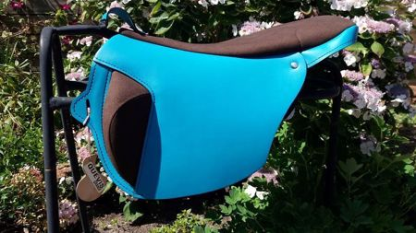
The Seat

Flap
Thigh block

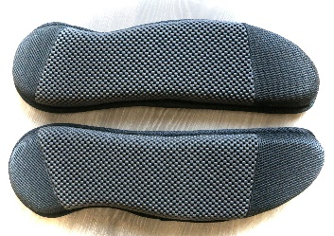
On some models, the thigh blocks can be ordered straight or angled. This must be considered for rider comfort based upon their anatomy and riding style.
The flap varies from model to model and is purely considered with rider preference, either visual appeal or to fit within their riding activities.
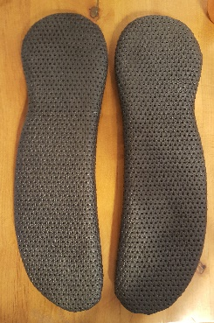
Panels
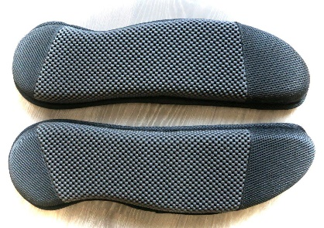
Panels are designed to distribute weight, create a spine channel to protect your horse, and add cushion.
They are available in #3 (left) in standard or XL (wide) with a Velcro opening which is useful if you need rider balancing shims, and #4 (right) which has a more elegant look and can be used with a velcro pocket shim if balancing is needed.

